# INFO 1531 – Assignment 9 – Database SQL

Directions: Screenshots should be of the SQL Execution tab on the DB browser. I want to see the command you type and the output that is produced. I don’t want to see just the data. Those screenshots in the assignment are for you to compare with your output making sure that you have all the data. I will be able to check the data of the classes added, deleted, and modified from the db file.

*To take a screenshot on Windows you can either hit the “Print Screen” button that is on the function keys or press Windows + Shift + S to go to the snipping tool, click and drag an area you are snipping. Then paste it into this document.*

*To take a screenshot on Mac you can hit Cmd + Shift + 4, then click and drag an area for a picture. It then gets saved to the desktop which you can insert into this document. (Alternatively hit Cmd + Ctrl + Shift + 4 takes the picture but saves to clipboard and doesn’t make a copy on the desktop)*

Example Screenshot:

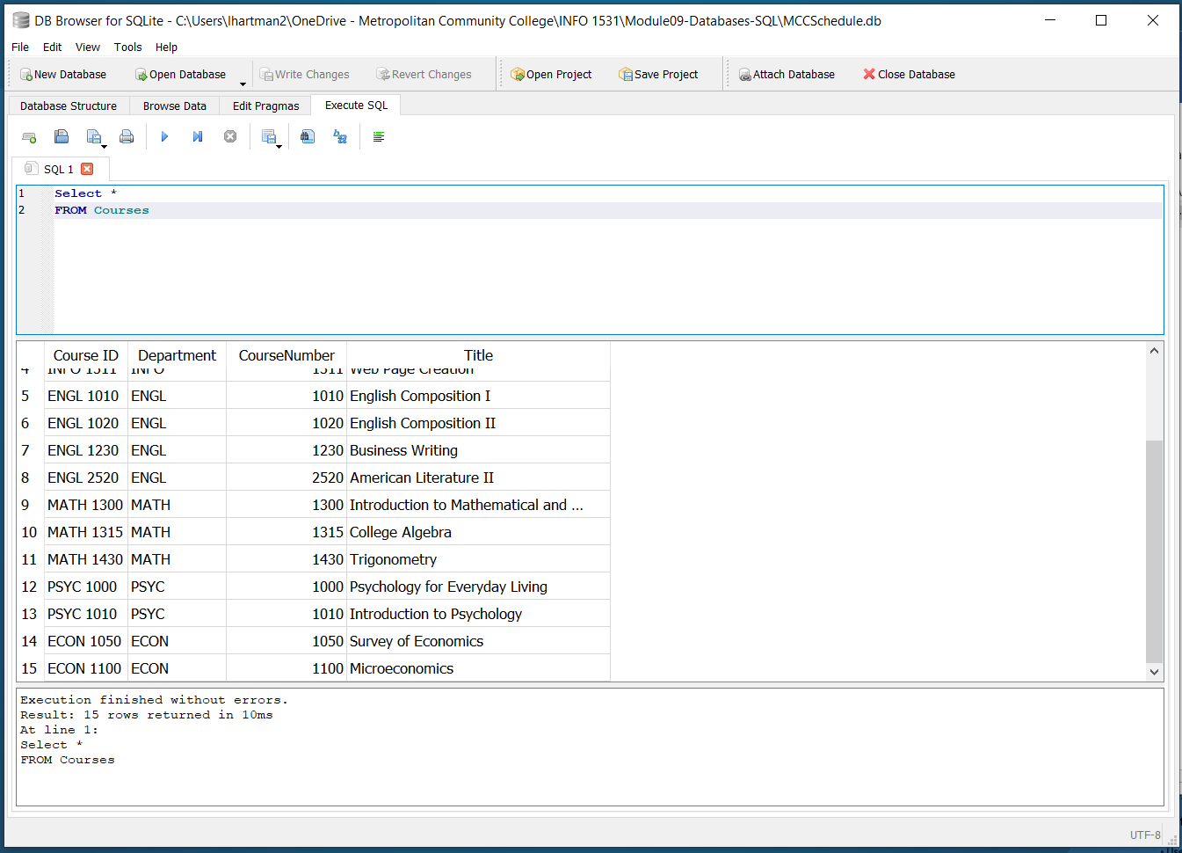

## Part 2: Query Data

### Screenshot of all INFO classes:

### Screenshot of classes that Hartman, L teaches:

### Screenshot of all classes that are on Monday and Wednesdays with Title:

## Part 2: Add, Deleting and Updating

### Screenshot of adding a class to Course Table:

### Screenshot of adding first class to the Schedule table

### Screenshot adding second class to the Schedule table

### Screenshot of deleting the Math 1300 class from Schedule Table

### Screenshot of deleting the Math 1300 class from Course Table

### Screenshot of updating all the locations with adding “Campus” to the end of each

